**Database** is a container which holds tables and other related SQL structures related to those tables.

Every time you search online, go shopping, call information use your Bank Card, make a reservation, search a movie online or buy products form online shopping websites, a database is being asked for information, otherwise known as being **queried.**

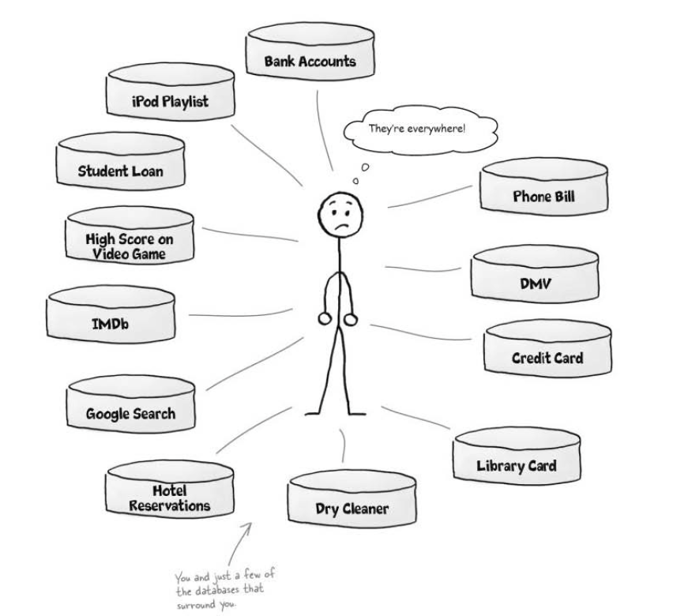

* A **database** contains tables.
* The information inside the database is organized into **tables.**
* A **table** is the structure inside you database that contains data, organized in **columns** and **rows.**
* Each category becomes a **columns** in your table.
* A table row contains all the information about one object in your table.

**Commands:**

* To create a database:

**CREATE DATABASE <**database_name>**;**

* you need to tell the RDBMS to actually use the database you just created.

**USE** <database_name>**;**

**Q:** **Why do I need to create a database if I only have one table?**

A: The SQL language requires all the tables to be inside of databases. There are reason behind this. One to the feature of SQL is the ability to control access to your tables by multiple users. Being able to grant or deny access to an entire database is sometimes simpler than having to control the permission on each one to multiple tables.

**Q: I noticed that we used all uppercase for the CREATE DATABASE command. Is that necessary?**

**A:** Some systems do require certain keywords to be capitalized, but SQL is case insensitive. That means it’s not necessary to capitalize commands, but it’s considered a good programming practice in SQL.

The Capitalization makes it easy to tell the command (CREATE DATABASE) from the name of the database (<database_name>).

**Q: Is there anything I should know about naming my database, tables, and columns?**

**A:** It’s generally a good idea to create descriptive names. Sometimes this results in you needing to use more than one word in a name. You can’t use spaces in you names, so the underscore lets you create more descriptive names. Here are variations you might see used:

* **table_name**
* **tablename**
* **Tablename**
* **tableName**

generally it’s best to avoid capitalizing your names to avoid confusion since SQL is case insensitive…

**Q: What If I prefer to use “tableName” with no underscore?**

**A:** Go right ahead. The important thing is to be consistent. If you use **tableName** with no underscore and the second word capitalized, then you should stick to that naming convention. Throughout all your tables in this database, for example naming you table myContacts, to be consistent.

**Q: Can I give a name like greg’s_list? why leave out the apostrophe?**

**A:** The apostrophe is reserved for a different use in SQL. There are ways you could include one, but it’s far easier to omit it.

**Q: I also noticed a semicolon at the end of the CREATE DATABASE command. Why did we need that?**

**A:** The semicolon is there to indicate that the command has ended.

**Capitalization and underscores help your program in SQL (even though SQL doesn’t need then!)**